**Deploying Fullstack Web Application Over AWS Cloud (Capstone project no 3)**

**Process:**

**Set Up AWS Resources**

Logged in to AWS Management Console.  
• Launched EC2 Instance: (virtual machine - Ubuntu).

And security groups to allowed HTTP (port 80) and SSH (port 22) traffic with instance type - T2.medium and 20Gb disk size and created PPK file.

**Connect to Your EC2 Instance**

•    Used SSH to connect to EC2 instance using the PPK file via Putty as below.

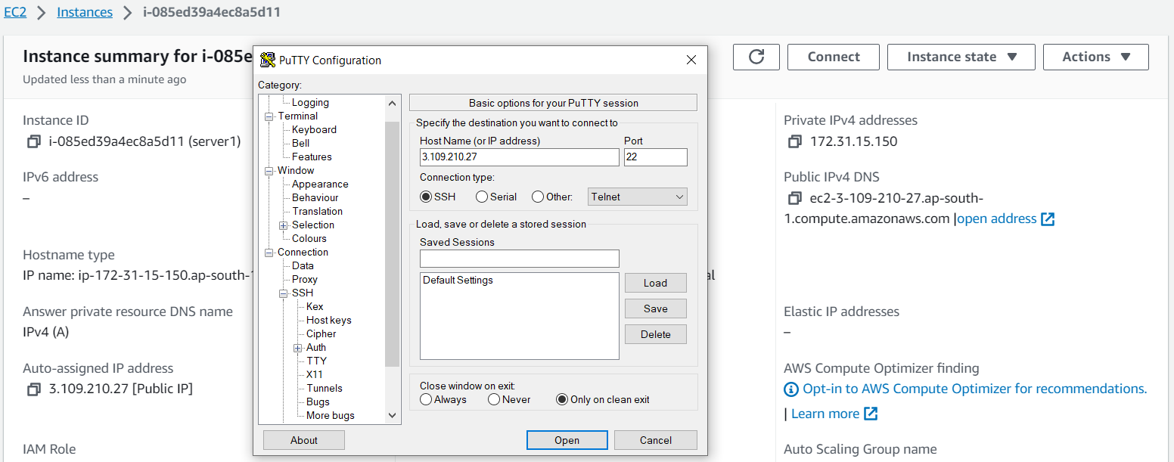

**Installed node.js on to server as below:**

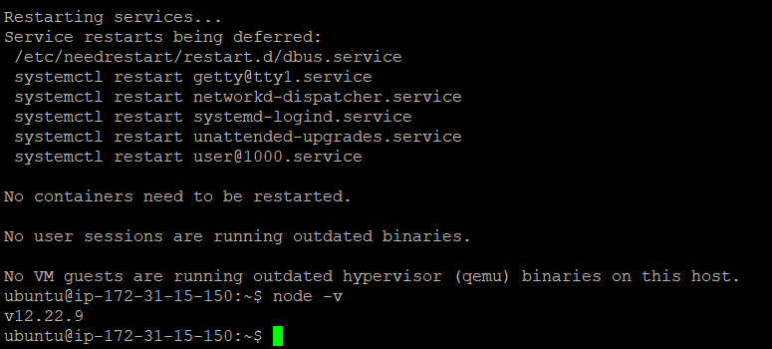

**Installed npm on to server for download the dependencies required for running app as below:**

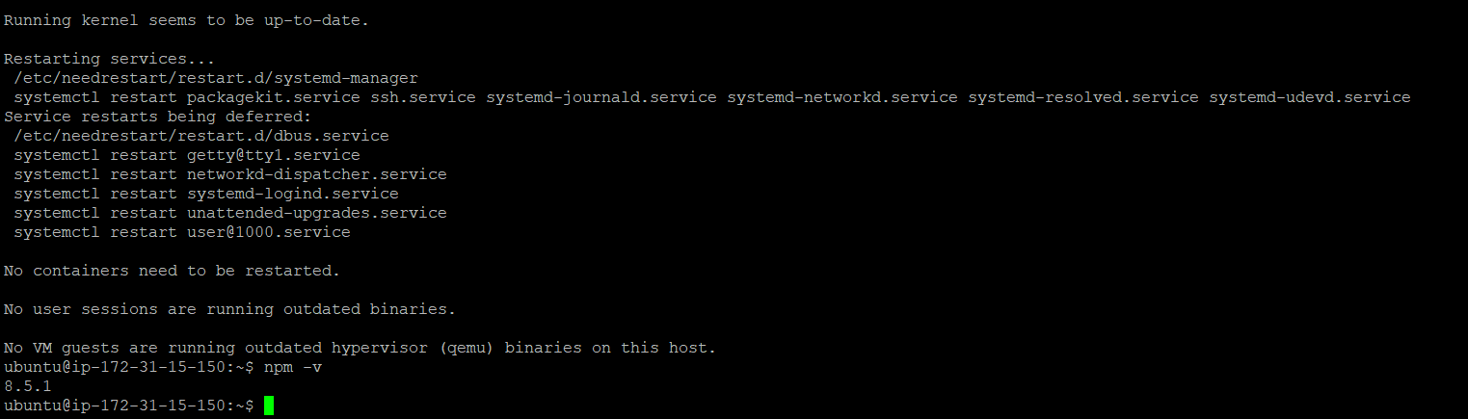

**Installed git on local machine**

**Git Repository :** <https://github.com/samaronybarros/movies-app/tree/master>

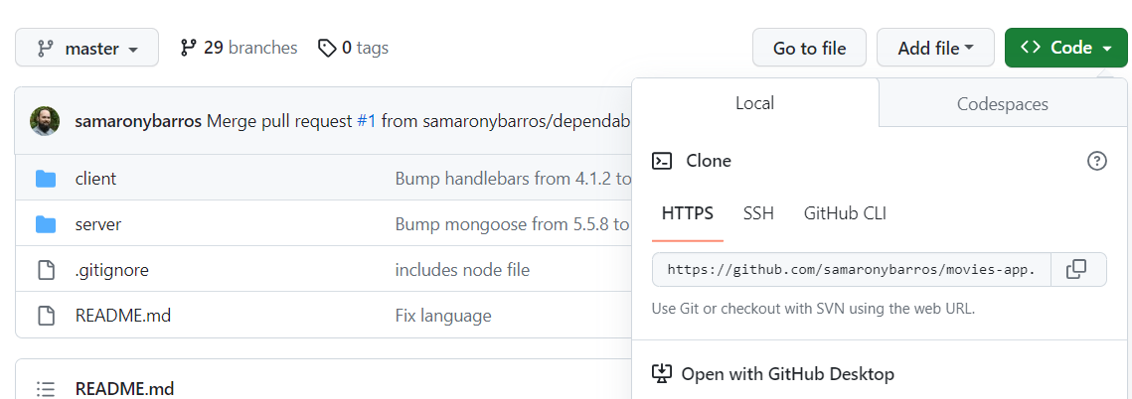

**For pulling the code to server from git hub used below command:**

**git clone** <https://github.com/samaronybarros/movies-app/tree/master>

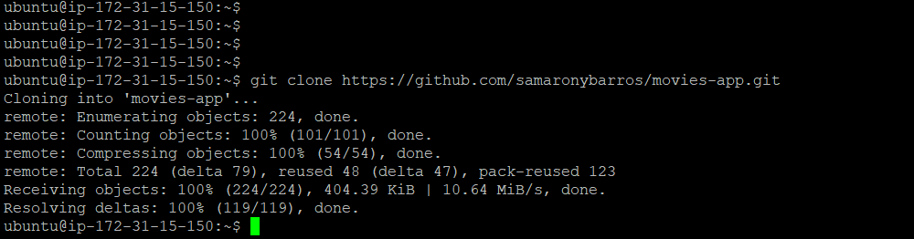

**Change directory to front end repository as below:**

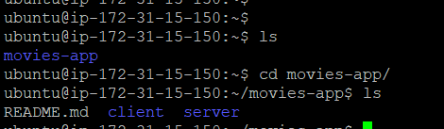’’

**Installed npm for download the package required for running app as below:**

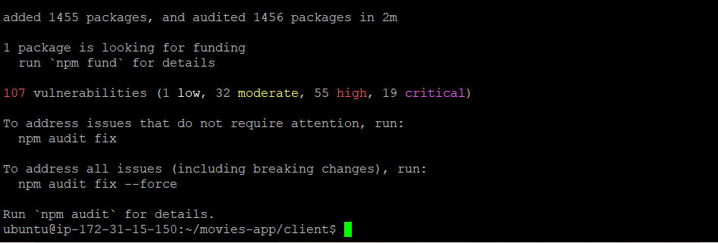

**After installing all packages need to start the app using below command:**

* **npm start**

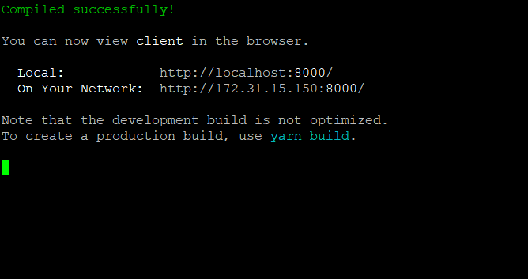

**And added port number entry(8000) in SG where the frontend app is running so that Machine can access.**

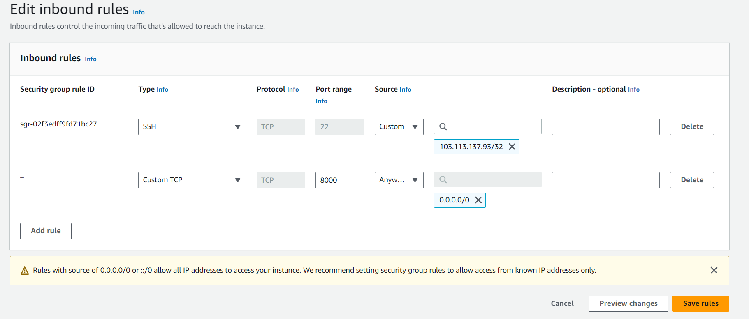

**And hit the public ip with the port number for viewing the frontend page.**

**Publicip:8000**

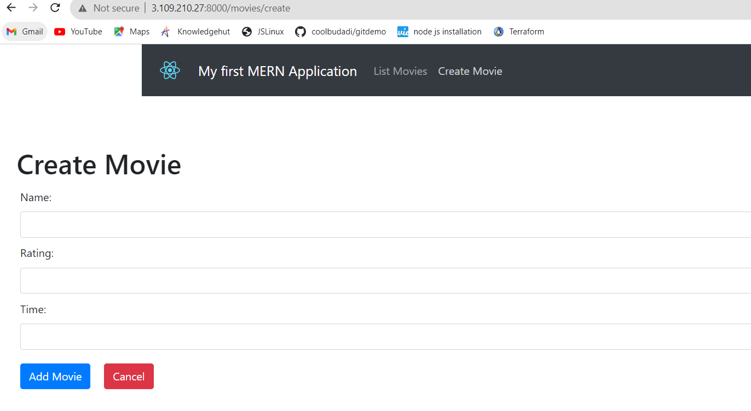

**Here I used database as MongoDB so installed same on the server and added port entry in SG.**

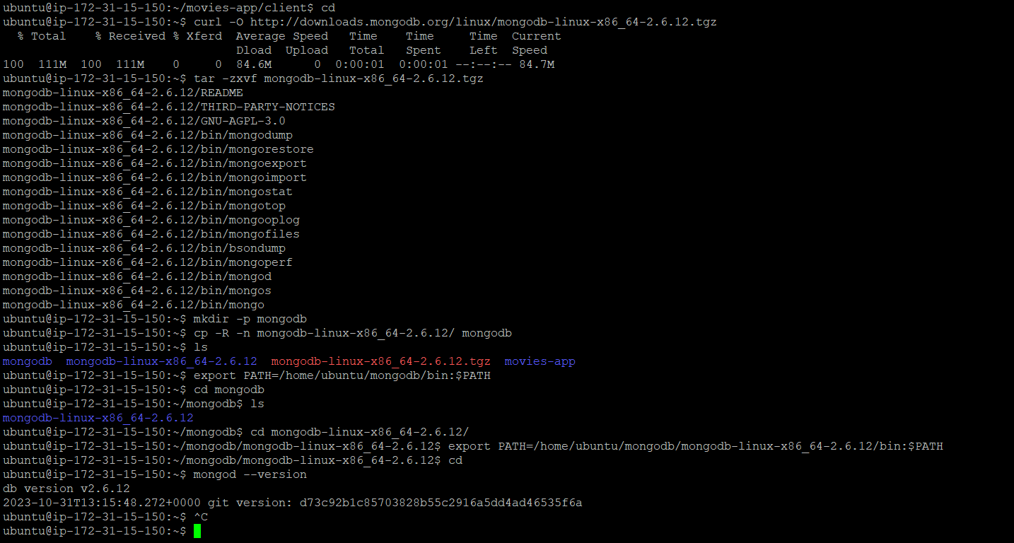

**Done some coding level changes in index.js file in frontend(code) for connecting frontend to backend as below**

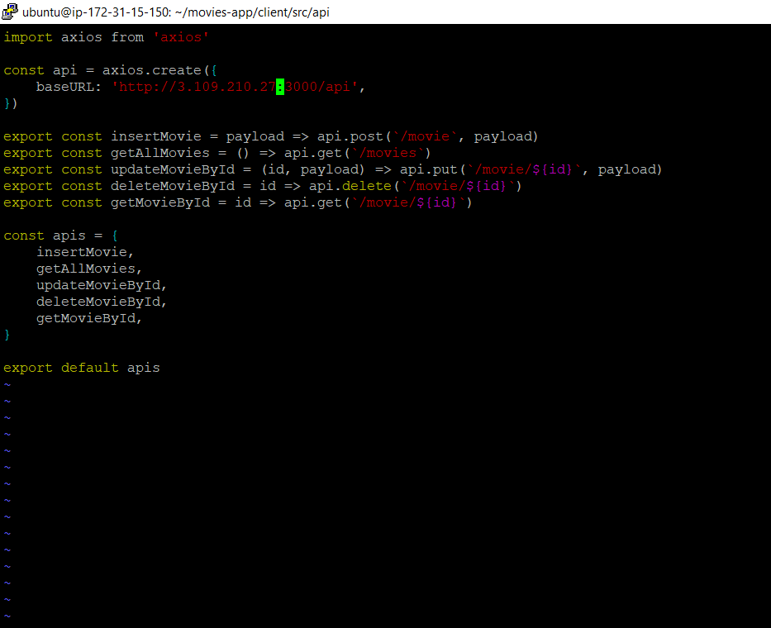

**Done some coding level changes in index.js file in backend(code) for connecting backend to database as below.**

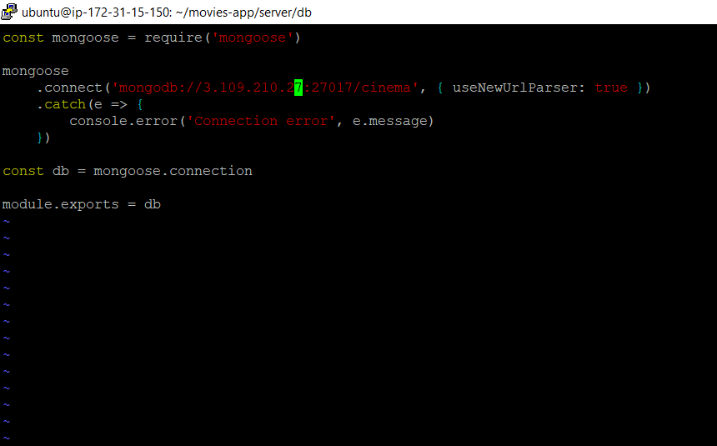

**Now changed directory to backend (server) and installed npm and start the**

**Application as below:**

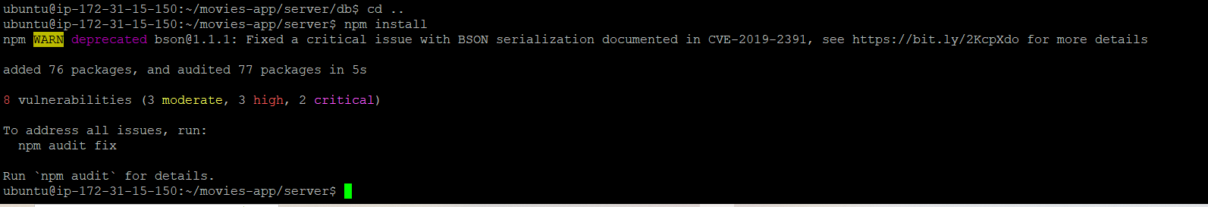

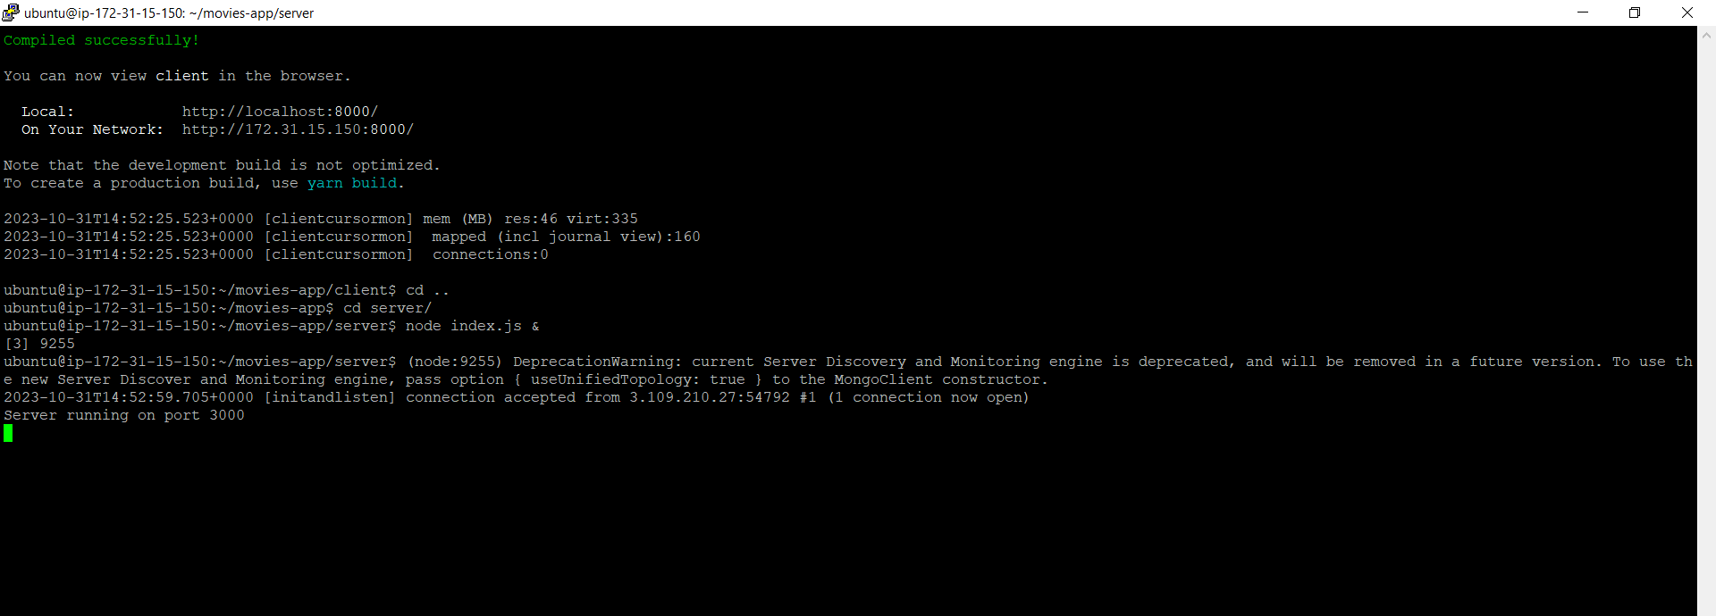

**Added port(3000) entry in SG as below:**

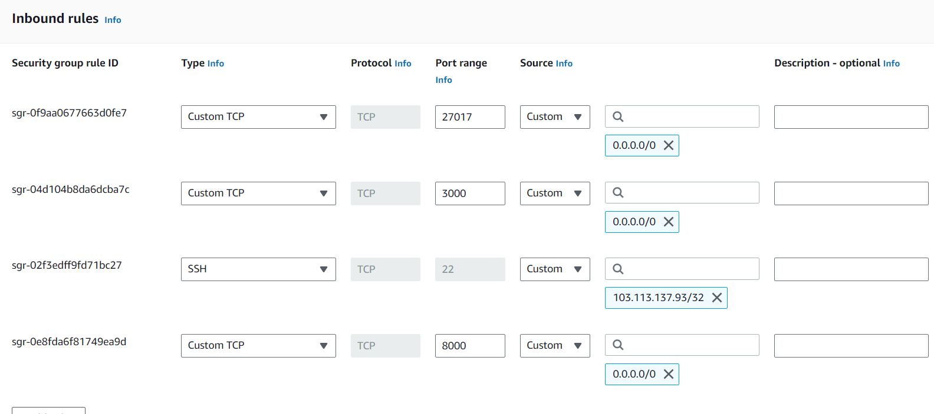

**And hit the public ip with the port no for viewing running app.**

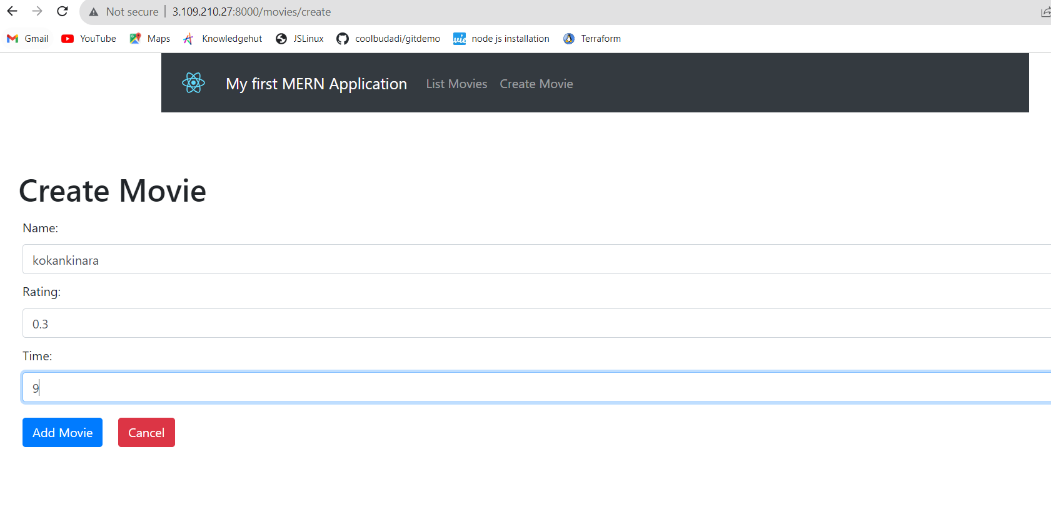

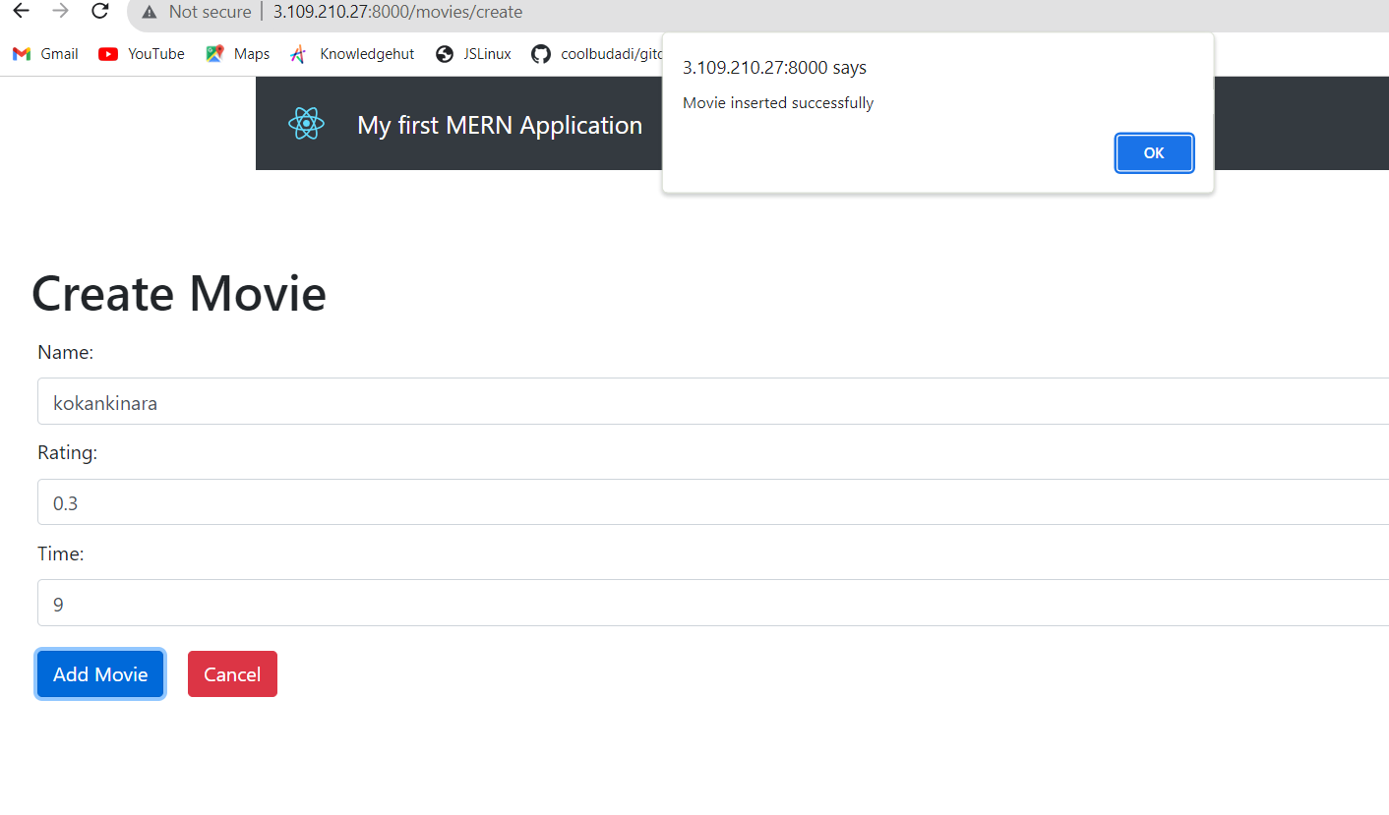

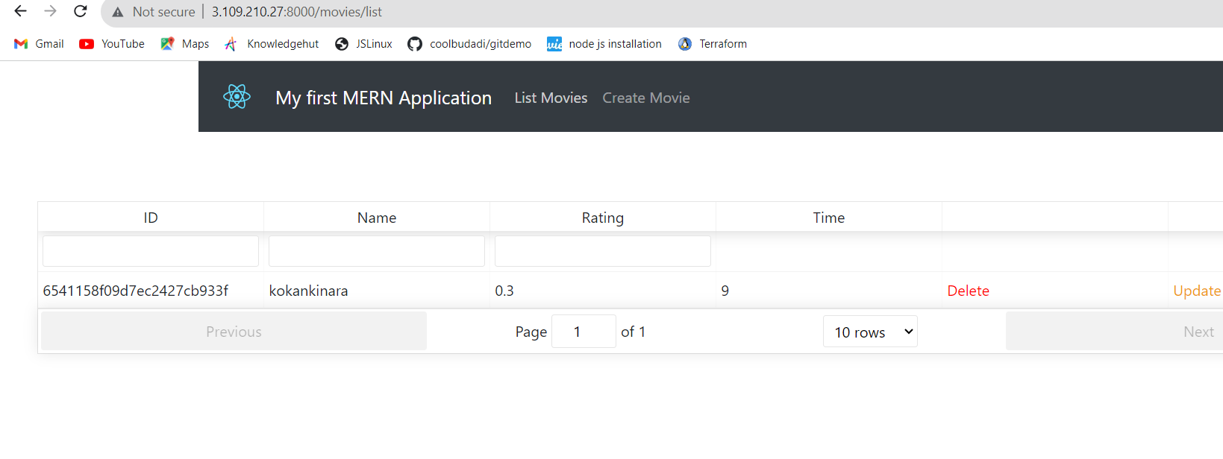

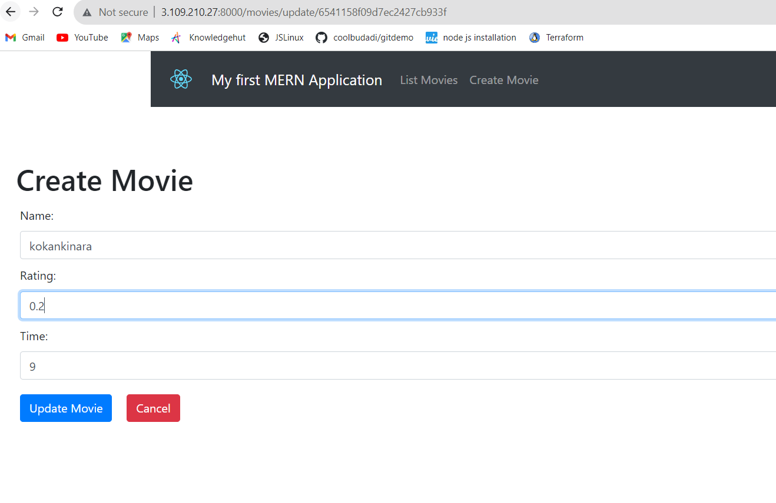

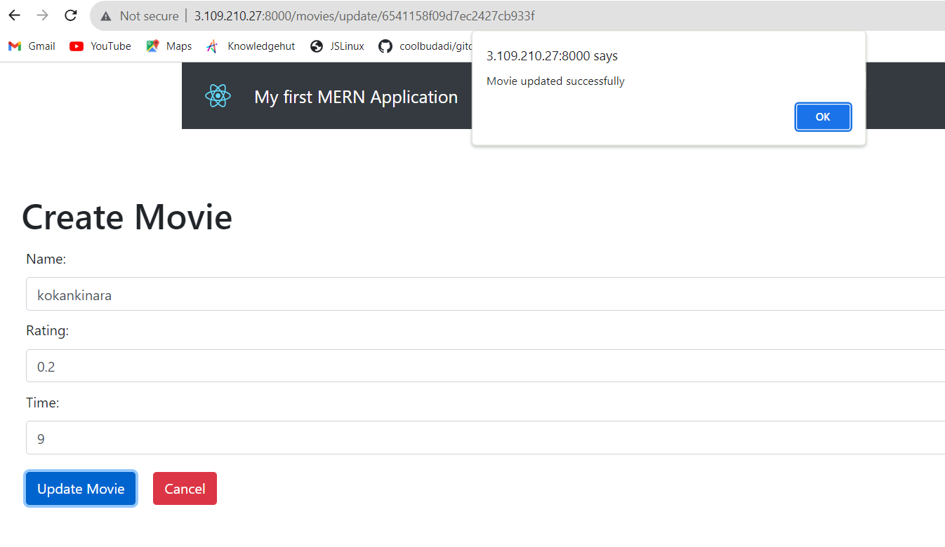

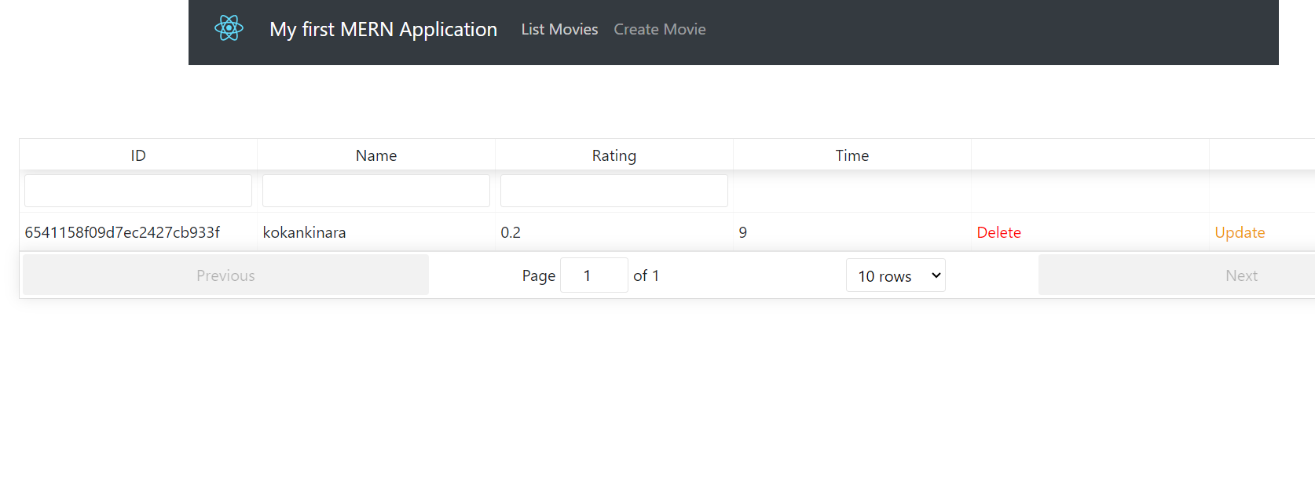

**For Monitoring used cloudwatch as monitoring tool for application performance as below.**

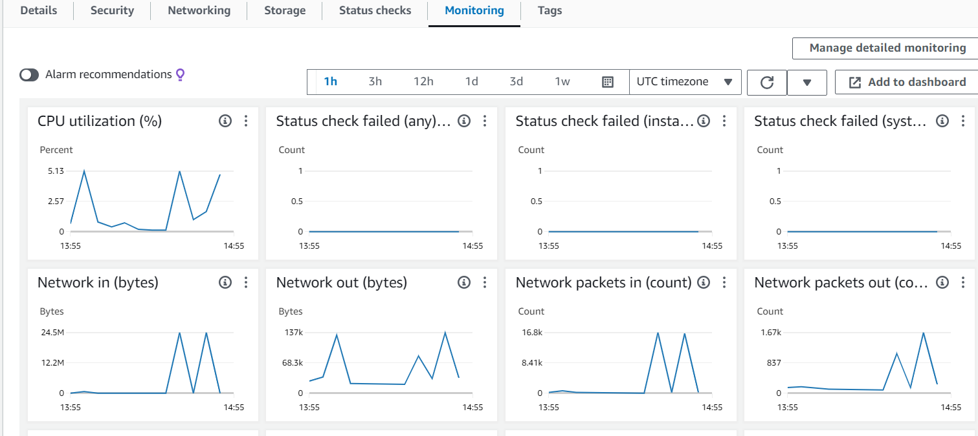

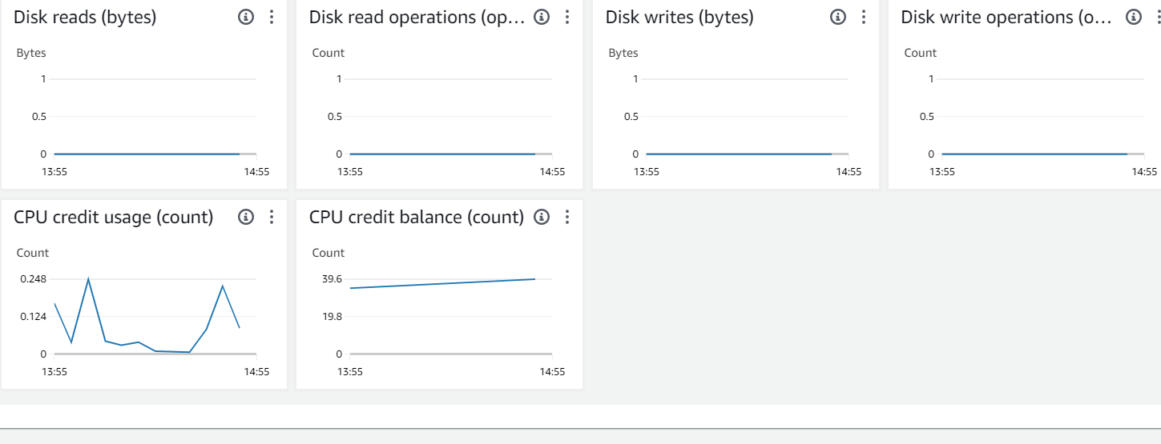

**Created alarms for triggering alerts using cloudwatch as below.**

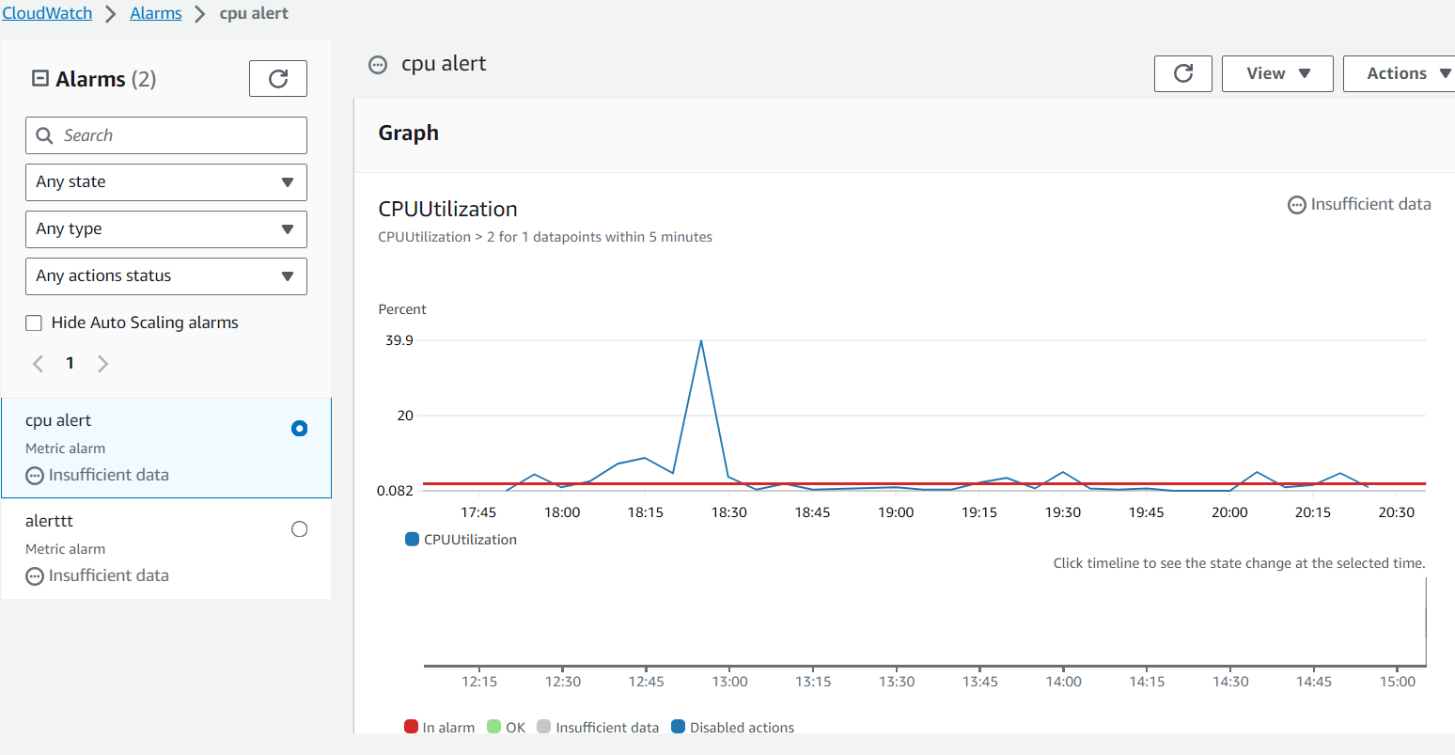

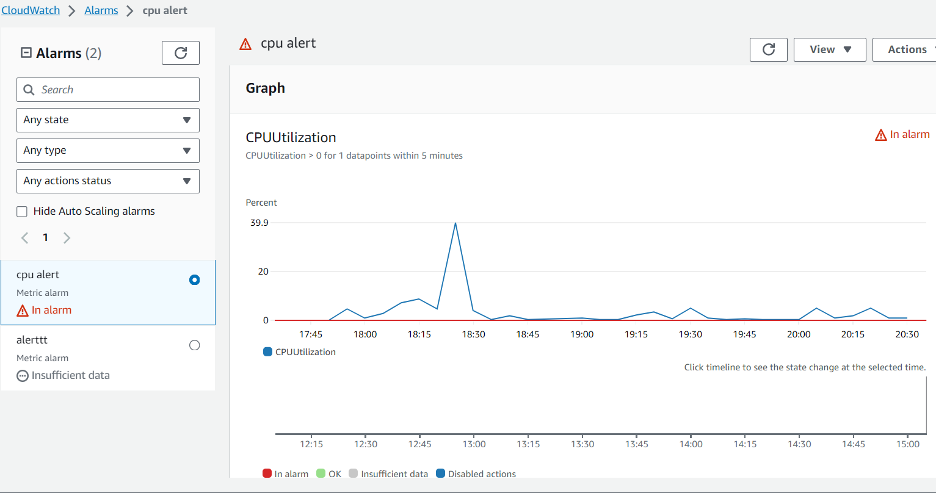

**Also using SNS topic set the alert notification to personal mail as below.**

